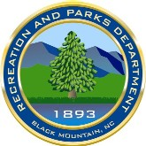
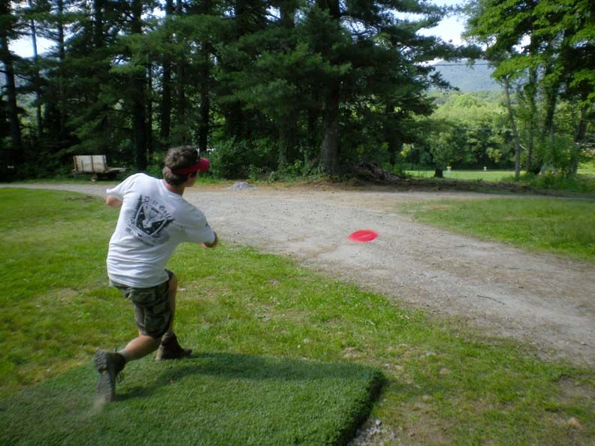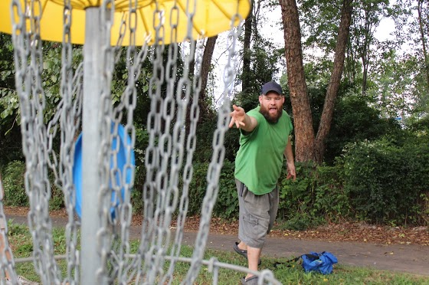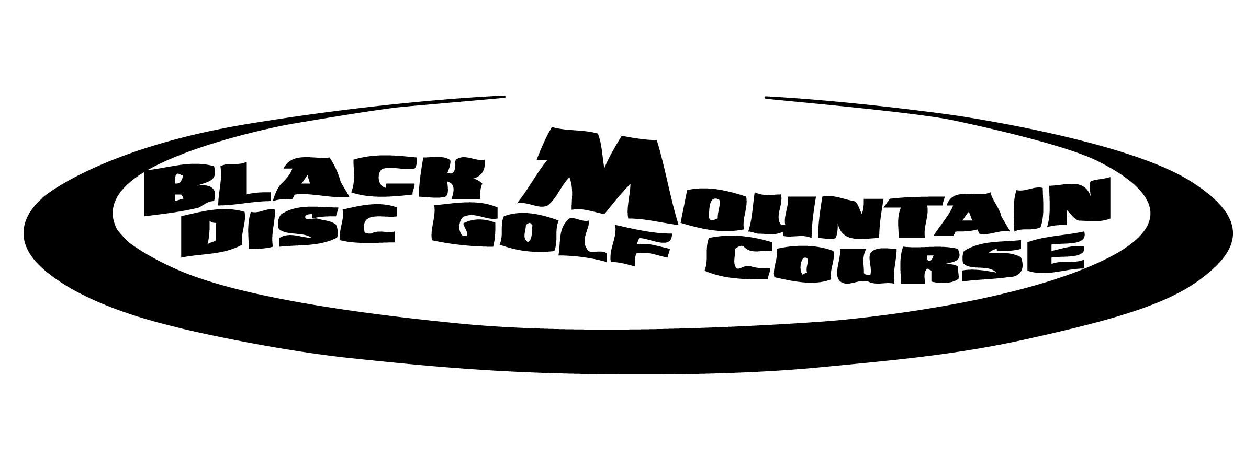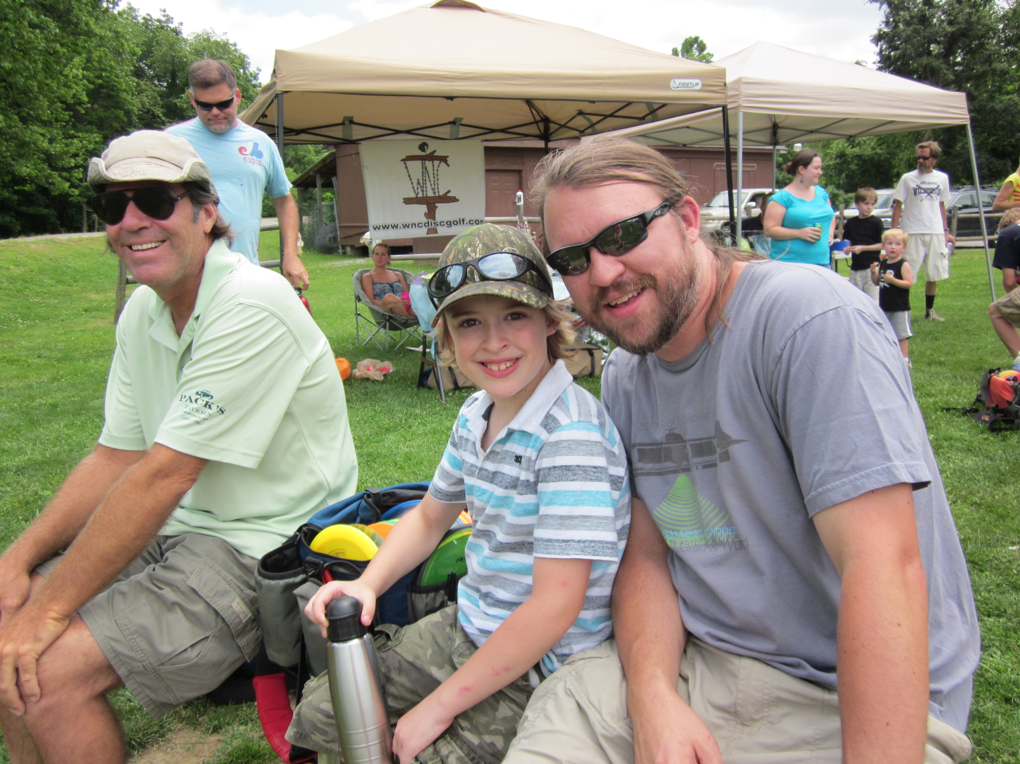
Disc Golf Course Sponsorship
2014-2018
Our Mission

To create a sponsorship program to help support our disc golf course.

Disc Golf Course Sponsorship 2014-2018

- Over 500 players per month. Based on numbers obtained during a voluntary count during 2012.
- Disc Golf can be played from school age to old age and making it one of the best lifetime fitness sports that can be played by people of all abilities.
- Black Mountain Disc Golf Course is a great place for beginners, families, as well as more advanced players by using our multiple tees on each hole.
- Players and their families spend money locally on their food / lodging / entertainment during visits.
- Players from over 23 States have visited our course according to dgcoursereview.com
- The course will introduce (or remind) participants of the advantages of visiting Western North Carolina, which will encourage return trips.
- Black Mountain Disc Golf Course is the beneficiary of all sponsorship money raised.

Sponsorship Levels
All Sponsors | - Use of the Black Mountain Disc Golf Course name/logo in your own promotions and advertising
SILVER ($100)  Sponsor | - Name/Logo in printed material and on the website (with link)  - Name/Logo in the third sponsor grouping on kiosk
GOLD ($250)  Sponsor | - Name/Logo in printed material and on the website (with link)  - Name/Logo in second sponsor grouping on kiosk  - Display their logo exclusively on one tee sign
PLATINUM ($500)  Sponsor | - Name/Logo in printed material and on the website (with link)  - Name/Logo in Premier sponsor location on kiosk  - Explicit and audible “thank you” and appreciation in PA announcements at Events  - Display their logo exclusively on one tee sign

2014-2018 Corporate Sponsorship Form

____________________________________________________________________
Name of Company/Institution/Organization -- Print EXACTLY as it should appear in all public use
______________________________________________________________
Website Address -- for public use on the Recreation & Parks website and other promotions

BILLING INFORMATION

______________________________________________________________

______________________________________________________________
Bill-to Address (Please, no PO Boxes) – This will not be used publicly
________________________________________________________________
Contact Name & Title Cell Phone (will not be used publicly)
_________________
Email Address

Choose Sponsor Level Determine Value of Total Contribution
⃝ SILVER Sponsor $100 Cash $______________
⃝ GOLD Sponsor $250 Gifts In-Kind (from below)
⃝ PLATINUM Sponsor $500 $__________ (FMV) x 50% = $______________

Total Sponsorship Fee $______________

Describe In-Kind Gifts
Quantity | Description | Fair Market Value
 | TOTAL Fair Market Value (FMV)

Note: Organizer may require additional documentation to support the value of in-kind donations prior to accepting such donations as credit towards Corporate Sponsor’s sponsorship fee.
Disc Golf Course
SPONSORSHIP AGREEMENT
This Sponsorship Agreement (“Agreement”) is entered by and between the organization identified in this document as the “Corporate Sponsor”, and Black Mountain Recreation & Parks, (the “Organizer”) and sets forth the terms and conditions upon which the Corporate Sponsor agrees to support the Black Mountain Disc Golf Course (the “Facility”).
- General. The Facility is to promote local businesses in Western North Carolina and benefit Black Mountain Disc Golf Course projects.
- Term. This Agreement shall be effective from the date of sign posting through the date five years after sign have been posted.
- Logo Due Date. Corporate Sponsor must provide payment and logo in suitable format prior to April 1, 2014. Logos provided after April 1, 2014 may not be used.
- Organizer’s Licensed Marks. Organizer grants Corporate Sponsor a limited, non-exclusive license to use the Black Mountain Recreation & Parks name and accompanying logo service and/or trade marks solely to promote the Facility during the Term of this Agreement. Corporate Sponsor shall not sublicense or transfer the use of the name or marks to any person or entity without prior written consent of Organizer. All advertising and promotional materials should refer to Corporate Sponsor’s relationship to the Facility in the following form: “Sponsor of the Black Mountain Disc Golf Course”.
- Corporate Sponsor’s Licensed Marks. Corporate Sponsor grants Organizer a limited, non-exclusive license to use Corporate Sponsor’s name, logo, service and/or trademarks solely for including Corporate Sponsor in listings and descriptions of Facility sponsors during the Term of this Agreement. Organizer shall not sublicense or transfer the use of the name or marks to any person or entity without prior written consent of Corporate Sponsor.
- Benefits and Payment. Corporate Sponsor shall receive the sponsorship benefits set forth in this Agreement. In consideration of the rights granted, Corporate Sponsor shall pay its sponsorship fee on or before April 1, 2014 and failure to do so shall result in a forfeiture of Corporate Sponsor’s sponsorship rights.
- Value of Contribution. Corporate Sponsor acknowledges that the tax-deductible amount of the contribution for Federal income tax purposes is limited to the excess of the money and in-kind gifts less the value of goods and services provided by Charity and/or Organizer and that Corporate Sponsor will seek their own tax advisor’s counsel in such matters.
- Program Cancellation. Organizer will not be responsible for damages that result from delays or postponements of the Program due to circumstances beyond their reasonable control. If the Program does not take place, sponsorship will be returned if funds are available.
- Insurance. Organizer shall ensure that insurance is in place for the program in the amount of at least $1,000,000 per occurrence to cover liability for bodily injury, property damage and death arising out of the activities in connection with the Program.
- Indemnity. Each party to this Agreement indemnifies and hold the other harmless from and against any and all expenses, including reasonable attorneys’ fees, that the other party may incur by reason of any claim arising out of the indemnifying party’s negligence, intentional misconduct, performance, or failure to perform pursuant to this Agreement, or any service or product sold or provided by the indemnifying party in connection with the Program.
- Corporate Sponsor Personnel. All individuals provided by or associated with Corporate Sponsor who perform services at the Facility shall perform such services at the direction of, under the supervision and control of, and for the benefit of Corporate Sponsor. Such individuals shall not perform such services on behalf of the Organizer, and shall not be agents or representatives of Organizer. Corporate Sponsor shall be responsible, as between Corporate Sponsor and Organizer, for any injuries or damages caused by or to said individuals.
- Entire Relationship. The parties to this Agreement have no legal relationship other than as contracting parties to this Agreement, and this Agreement represents the entire agreement between the parties and supersedes any prior understandings or agreements.
- Sign Condition. The Organizer will be responsible for maintaining sponsor signs in a presentable fashion.
- Governing Law. This Agreement shall be governed by the laws of the State of North Carolina.
Signatures & Payment
⃝ Full Payment Enclosed Make checks payable to “BMRP” or “Black Mountain Recreation & Parks”
⃝ Credit Card Credit Card instructions available upon request
⃝ Please Send Invoice

Signature for Corporate Sponsorship Printed Name / Title Date

Signature for Organizer Printed Name / Title Date

FULL PAYMENT, EXECUTED AGREEMENT & LOGOS DUE BY April1, 2014
Mail this completed agreement and your check to:

Black Mountain Recreation & Parks
101 Carver Ave.
Black Mountain, NC 28711

For More Sponsor Information & Assistance:
Casey Conner 828-669-2052 or casey.conner@townofblackmountain.org

